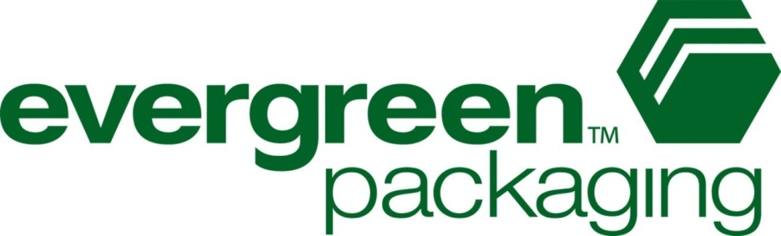
Evergreen Packaging in Raleigh makes cartons for school milk. They have just been told by the milk distributor that they want to change the volume of milk that is in each carton from 8 oz to 10 oz. This will require a new carton to hold the extra 2 oz.

They want to take this opportunity to try a new shape for their cartons to try and bring attention to their product. You are tasked with designing a new carton for the milk.

Your carton must be made from one cut of paper and then folded into the carton. You will have to provide the following specifications with your carton design:

1) The design of the net (the unfolded shape) of your carton
2) The layout of the stamp that will cut the shapes out of the paper (remember, you want to minimize waste!)
3) An account of how much waste will be produced per sheet of paper
4) A finished example of what the carton will look like folded and finished.
5) A description of dimensions proving the volume of the carton will hold the 10 oz of milk with minimal wasted space (air) in the carton.

You will be presenting this information and your prototype carton to representatives of Evergreen packaging. This will be a formal, business presentation.

Got Milk? Group Project Document 1

Each member of the group will need to complete a column of the table below individually by the first checkpoint.

To individually complete your section of this table you need to...
- Design a carton. You will need to create a net for the carton that can be folded into the carton. Don’t forget to include tabs on the sides that need to be glued/sealed together.
- Once you have your net design you need to label with measurements and dimensions. Don’t forget to include units of measure.
- Once you have measurements, you will need to fill out the table below to find the surface area and volume for your carton. Remember, you want your carton to hold 10 oz of milk with little wasted space as well as minimal surface area (less paper needed).

Group Member 1 Group Member 2 Group Member 3 Group Member 4
Name of member

What shape(s) is your carton? (If it is a combination of more than one 3D shape, list them all here)
Find the volume of each of these shapes individually, then combine them to find the total volume of your container. List all of the dimensions needed to find each volume.
Find the surface area of each of the shapes here. Please only find area of surfaces that would actually be part of the carton.
Find area of any tabs that are part of your net and will be used for glueing the carton together. Then add all the tabs and the surface areas you found above to find out how much paper your net would use.

Got Milk? Project Document 2

Group Member 1 Group Member 2 Group Member 3 Group Member 4
Name of member

You will need to complete all of these tasks as a group to prepare for your final presentation.

- At checkpoint 2, you will all need to compare your designs and decide as a group which design you like best. You will want to consider all factors such as best volume, least paper used, overall aesthetic and marketability.

- Once you choose a design, you need to design the cutter that will stamp the shapes out of the sheets of paper at the plant. Remember, you want to get as many of the nets as possible while wasting as little paper as possible. You will then need to find out how much waste (unused paper) do you expect from each sheet of paper at the plant.

- You will need to design what the images on the sides of your carton will look like. Remember there is a lot of required information that you will have to include, so make sure you do your research. Be careful with colors. When printing, each different color has to be printed separately and therefore each separate color costs more money! Get creative!

- You need to make a prototype of your carton that is folded, glued, and has the design printed on it. A final product.

- You need to create a presentation to present your final prototype. It needs to include your net design, proof of its volume and surface area, the layout of the stamp for cutting, the amount of wasted paper for each sheet, and the design for the carton. You are pitching your design so you really want to sell it and explain why yours is the best.

